How To Prevent Bearing Failure and Determine Their Causes
Engine Bearings depend on a film of oil to keep shaft and bearing surfaces separated (figure A). Bearings fail when the oil film breaks down or when the bearing is overloaded. The oil film is generated by shaft rotation (figure B). At rest, the shaft and bearing are in contact. On start up the shaft rubs the bearing briefly. Running, the shaft pulls oil from the clearance space into the wedge shape area between the shaft and bearing. The oil wedge lifts the shaft off its bearing and supports it during engine operation. With normal operating conditions and a continuous supply of clean oil the shaft and bearing surfaces will remain separated.
When bearing damage occurs the cause must be determined and corrected before installing new parts

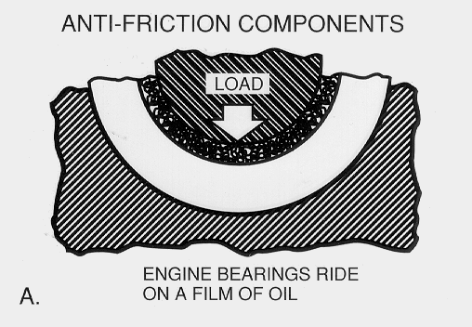

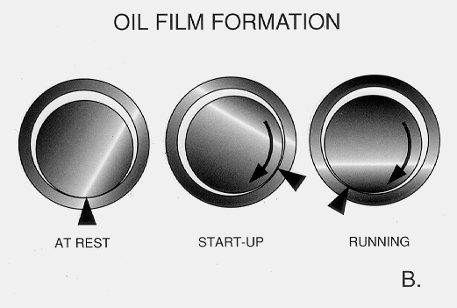

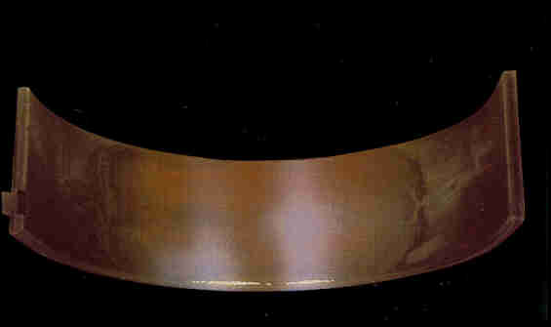
Appearance: Uniform wear pattern over approximately 2/3 of the bearing’s surface. Wear should diminish near the parting line ends of the bearing, and the wear pattern should extend uniformly across the bearing in the axial direction.

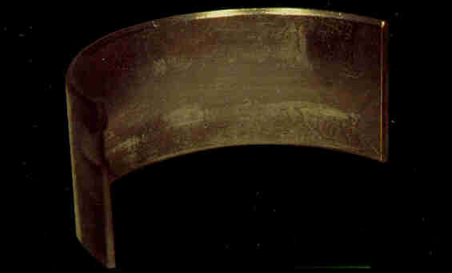
Appearance: Network of fine cracks in surface layer of a Trimetal bearing.
Causes: Overloading (lugging engine at low speed under high load, overfueling, detonation). Localized concentration of load due to misalignment (edge loading, bent rod, tapered, hourglass or barrel shaped housing or journal).
Note: Moderate overlay fatigue especially in localized areas may be considered part of the break-in process. Bearing may be re-used. Sever overlay fatigue, especially in a high-performance engine, may be due to the wrong bearing selection. Use of special competition parts with thinner overlay is recommended.

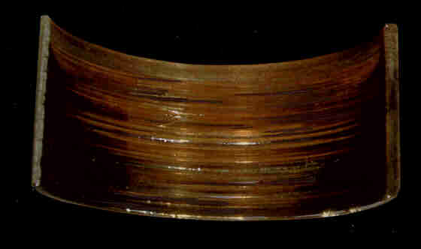
Appearance: Bearing surface deeply scratched and torn.
Causes: Excessive foreign particle contamination. Poor crankshaft surface finish. Insufficient lubrication.

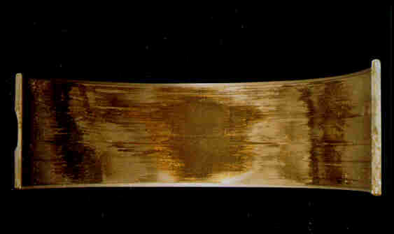
Appearance: Bearing surface darkened, spongy, etched by chemical attack.
Causes: Acids in oil. Excessive operating temperature. Excessive blow-by. Coolant contamination of oil. Use of high sulfur fuel. Excessive oil change interval.

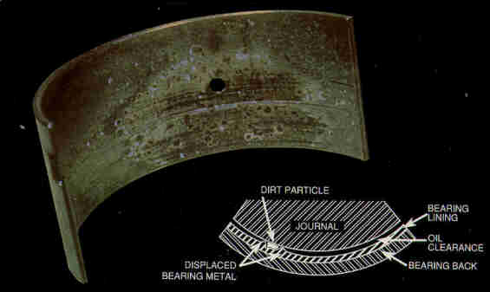
Appearance: Bearing surface speckled, darkened and lightly or heavily scratched.
Causes: Foreign particle contamination. Engine components not thoroughly cleaned prior to assembly. Wear particles from another engine component. Faulty air filtration. Neglected oil filter replacement. Dirt entering engine during oil addition.

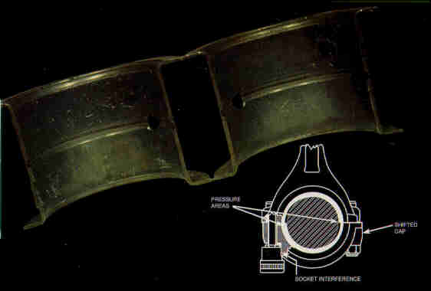
Appearance: Wear or fatigue near bearing parting lines on opposite sides in upper and lower bearing halves.
Causes: Mixed bearing caps. Reversed bearing cap. Poor doweling of cap to housing. Use of oversized socket. Housing not machined and assembled at same bolt torque. Mating faces of housing not flat and parallel.
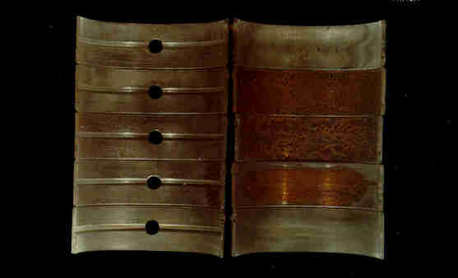
Appearance: With main bearings arranged as installed in the engine, bearings show a progression of damage from one to another.
Causes: Main bearing bores out of alignment. Engine overheating. Improper tightening of engine components (bearing caps, heads, manifolds, etc.) Engine not properly or uniformly supported (large stationary engines).

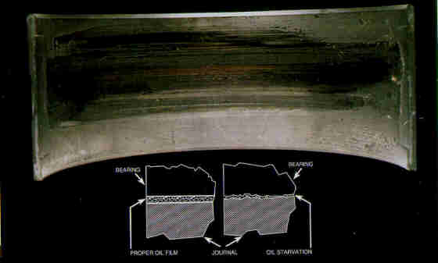
Appearance: Bearing surface streaked and smeared with worst damage at center. Hat discoloration. May show pick-up of bearing material on shaft depending on severity.
Causes: Low oil level, blocked oil pick-up, oil pump failure, blocked oil hole or oil passage, excessive dilution of oil by fuel or coolant, lubrication system not primed before start-up, overspeed.
Note: This condition will progress into “Wiping” and “Hot Short”.

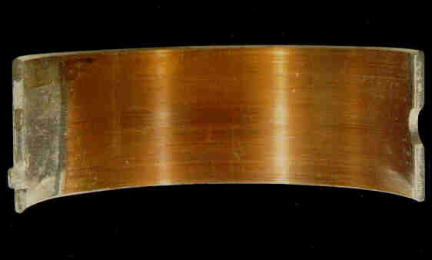
Appearance: Wall thickness reduced from original dimension. Bearing surface worn and polished but not smeared, torn, or scored. No evidence of heat, no embedded foreign particles.
Causes: Poor journal surface finish. Wear in the presence of adequate lubrication to prevent heat build-up and wiping is caused by peaks in the journal surface finish profile which penetrate the oil film and abrade the bearing. Always grind opposite to rotation and polish in the direction of rotation.

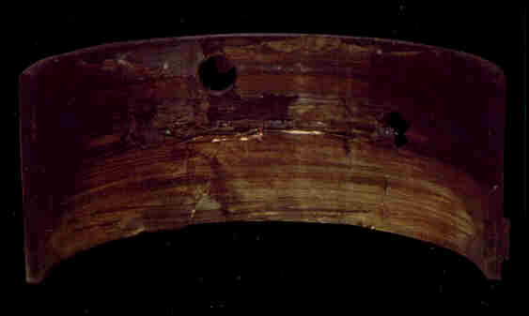
Appearance: Bearing surface wiped and torn, blackened from heat, with patches of lining material torn cleanly from steel backing.
Causes: Breakdown of lubrication and resulting high friction elevates operating temperature. Lead in bearing material melts and allows shaft to tear away patches of bearing lining. Lack of lubrication. Wiping. Dirt contamination. Concentrated loading (misalignment, etc.)

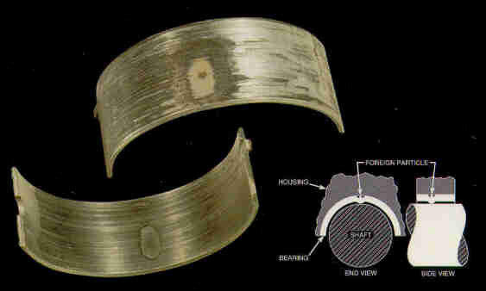
Appearance: Concentrated area of distress on bearing I.D. with corresponding mark or discontinuity on O.D.
Causes: Foreign particle trapped between bearing back and housing. Damage to bearing back or housing bore (nick, burr, etc.). High spot on bearing back or housing bore due to fretting.

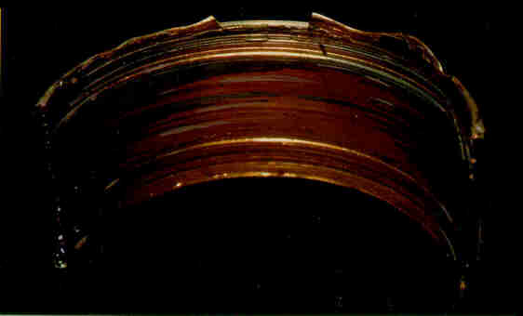
Appearance: Bearing surface smeared or scratched and torn. Bearing metal melted and re-solidified along edges.
Causes: Lubrication system not primed before start up. Clogged oil passage. Oil pump failure. Improper installation (oil hole blocked). Concentrated loading in localized area of bearing. Misalignment of shaft and bearing surfaces. Insufficient clearance.

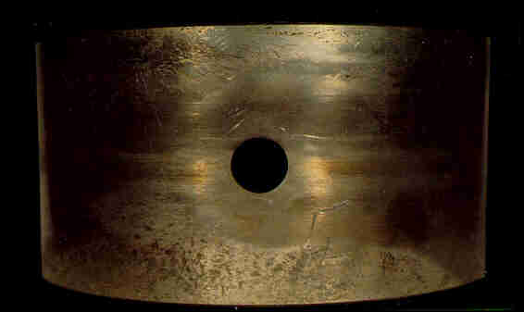
Appearance: Bearing back polished from movement in housing. Areas of pock marks or build-up due to metal transfer between bearing and housing.
Causes: Insufficient crush. Oversize housing. Bearing cap not torqued properly. Foreign objects between cap and housing faces. Over-stressed cap bolts.

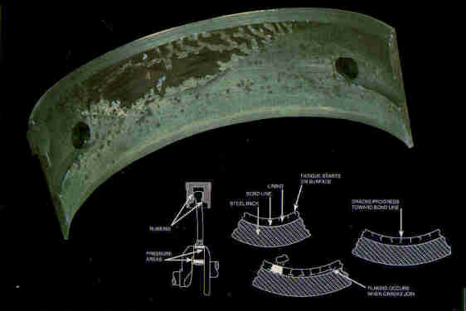
Appearance: Bearing surface cracked, areas of lining broken out leaving craters with ragged edges.
Causes: Overloading (lugging engine at low speed under high load, overfueling, detonation). Bearing material of inadequate fatigue strength for application. Localized concentration of load due to misalignment (edge loading, bent rod, tapered, hourglass, or barrel shaped housing or journal). Bearing lining weakened by corrosion.

Aluminum Bearings

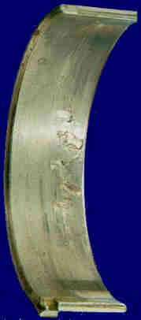 |  | Appearance: Bearing surface cracked, areas of lining broken out, leaving craters with smooth bottoms and rough sharp edges.  Causes: Overloading (lugging engine at low speed under high load, overfueling, detonation). Bearing material of inadequate fatigue strength for application. Localized concentration of load due to misalignment (edge loading, bent rod, tapered, hourglass, or barrel shaped housing or journal).

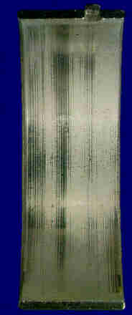 |  | Appearance: Wear patter covering approximately 2/3 of the bearing surface. Wear should diminish near the part line ends of the bearing surface. Pattern may be intermittent in both axial and circumferential directions on bimetal aluminum depending on geometry of mating surfaces.

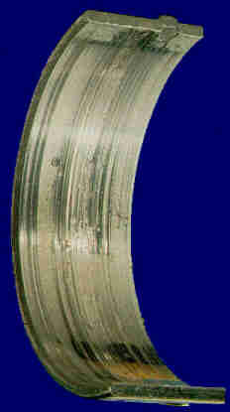 |  | Appearance: Bearing surface deeply scratched and torn.  Causes: Excessive foreign particle contamination. Poor crankshaft surface finish. Insufficient lubrication.

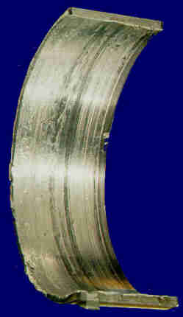 |  | Appearance: Bearing surface smeared or scratched and torn. Usually discolored from heat. Bearing metal melted and resolidified or extruded along the edges.  Causes: Lubrication system not primed before start up. Clogged oil passage. Oil pump failure. Improper installation (oil hole blocked). Concentrated loading in localized area of bearing. Misalignment of shaft and bearing surfaces. Insufficient clearance.

